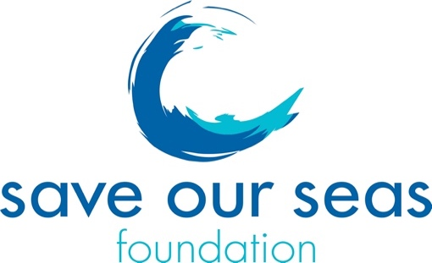
Budget Reallocation Request Form

1. Date of request:
2. Your full name:
3. Supervisor name:
4. Type of grant (small or keystone):
5. Year of grant awarded:
6. SOSF project number (on your SOSF agreement):
7. Project title:

8. Rationale for the Budget Reallocation Request :
(between 100 and 500 words)

9a. Please confirm the budget does not exceed the original approved amount:

9b. Please send your initial budget sheet + an amended budget sheet with amended figures in red and comments in the comments’ column.
10. Does this budget reallocation also have an impact on the planned end date of your project?
If yes, what is the new deadline that you consider feasible:

(please note that you have 3 months after 'end date' to provide the final report, unless you file a no-cost extension request.)
11. Which of your objective is concerned by this change in budget?

12. Other rational/comments for the budget reallocation :
(between 100 and 500 words)

13. Please provide the link of your SOSF webpage project: https://saveourseas.com/

14. After approval of your request, will you need an amended Annex2 reflecting this change for you or for your institution?

Once completed, please send this form to Sandrine Griffiths, Programme and Operational Director, on sandrine@saveourseas.com and copy James Lea, CEO, on james@saveourseas.com.

