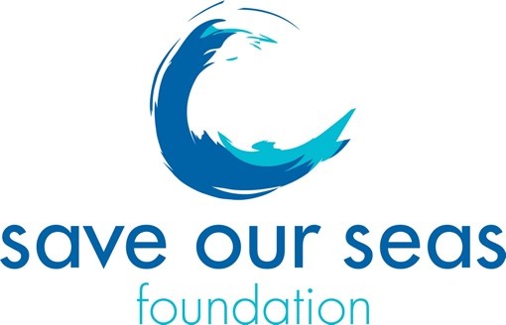
No Cost Extension Request Form

Your full name:
Supervisor name:
Type of grant (small or keystone):
Year of grant concerned by this request:
SOSF project number:
Project title:

Current planned end date:

The new project end date that you consider feasible is:

(please note that you have 3 months after 'end date' to provide the final report.)
Which of your objective is concerned by this delay?
Rational for the No Cost Extension Request :
(between 100 and 300 words)

Please provide the link of your SOSF webpage project: https://saveourseas.com/

After approval of your request, will you need an amended Annex2 reflecting this change for you or for your institution?

Any other comment:

Once completed, please send this form to Sandrine Griffiths, Grant Programme Manager, on sandrine@saveourseas.com and copy James Lea, CEO, on james@saveourseas.com.

