SOSF Final
Project Report

Small Grant ‘number’

‘Year(s) funded’

‘Total funding awarded (USD)’

‘Project title’

‘Year(s) funded’

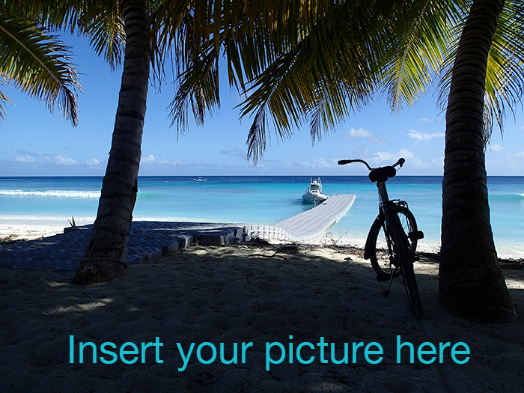
‘Project Leaders’ affiliations’

‘Project Leader(s)’
‘Collaborator(s)

Content

Executive summary

Introduction
General aim
Methods
Results
Conservation achievements
Education and public awareness achievements (if applicable)
Discussion
References

Outputs / Media / Communication
Published papers
Appendices

Financial statements

Your evaluation of the Save Our Seas Foundation

This report might be sent for external peer review, please indicate any non-preferred reviewer(s) (potential conflict of interest for example):

Are any of your results or conclusions confidential? Please indicate [confidential] before each section/paragraph when needed.

Executive summary

Insert your text (max 1 page)

Typically, an executive summary will
- consist of short and concise paragraphs
- start with a summary
- be written in the same order as the main report
- (make recommendations)
- (provide a justification)
- have a conclusion
- be able to be read separately from the main report

Summary of main research results/outcomes

(maximum 150 words, do not include anything confidential as this will be posted on the Save Our Seas Foundation's website)

Introduction

Insert your text

General aim

Insert your text

Methods

Insert your text, tables, figures, images…

Results

Insert your text, tables, figures, images…

Conservation achievements
Insert your text, tables, figures, images…

Education and public awareness achievements (if applicable)

Insert your text, tables, figures, images…

Discussion

Insert your text, tables, figures, images…

References

Insert the references

Outputs / Media / Communication

Insert your list and attach any document when available

Published papers

Insert your list of publications and attach the PDFs when available

Appendices

Insert your list

Financial statement

Insert a detailed financial statement for the funded year (tables could be sent as separate files)

Your evaluation of the Save our Seas Foundation

Please give us any feedback (positive and negative) about your collaboration with the Foundation

